Intimate bestiary : project specifications

# Project identification

**Project title**: Artexhibition (Initime Bestiary) showcase website

**Project starting**: 17 June 2024

**Project ending** : 15 September 2024

**“Customer”** : Oriane

**Key members:**

* @robo <https://github.com/sandesnp/>
* @Fabio
* @orianeords <https://orianeords.github.io/ORDSwebdev/>

**Management tools :**

* Discord webdev collab server[**https://discord.gg/fpF6758X**](https://discord.gg/fpF6758X)
* Add GitHub : <https://github.com/OrianeORDS/intimatebestiary>
* Trello Teams https://trello.com/w/intimatebestiary

# Project Scope

## Customer needs

Oriane exposes her art at a gallery near her home (Seine-Saint-Denis, France), in November 2024. The exhibition is called « Intimate Bestiary » and counts 9 large paintings and text (+some scultpures). It can be red from multiple angles, including the violences perpetrated against children and especially young girls.

Oriane would like to have **a showcase website t**o give her art (and his purpose) more visibility.

## Initial Stage

Oriane is part of a coding self-study group, from all over the globe ( <https://discord.gg/fpF6758X> ). Some of the members agreed on working together on the website, as a self-study project.

## Roles and Tasks

To be done

# Key Personas

## Website users might be

* People speaking French
* Mostly living near Paris
* Mostly women : from teens to elderly
* People interested in contemporary art
* People willing to fight against gender-based violences
* People willing to fight against violences towards children
* Victims of violences in a healing journey

## Political Agenda

Two political events are linked to the launch of the exhibition :

* 25th novembre : day for the elimination of violence against women
* 18th novembre : day for the elimination of violence against children
* <https://www.un.org/en/observances/ending-violence-against-women-day>
* <https://www.un.org/en/observances/child-sexual-exploitation-prevention-and-healing-day>

## SEO

* Bestiaire intime
* Maison des femmes
* Gallerie longue vue
* Oriane royon da silva
* Enfantisme
* Amnésie traumatique

The keywords for SEO should be written in French.

The inner and outer links should contend some of the keywords.

The website may content some presentation text besides the fotos of the exhibition

# Deliverables

* Artistic content (Intimate bestiary project : content) :
  + 9 photos => big format
  + 9 texts => may be read or heard by the user, on demand
* Mostly a main web page
* Maybe some animation features ?
* A static design proposition
* A (simple) HTML structure
* CSS worksheet > styling + mediaqueries
* Some JSS functionalities ?

# Visual Identity

**A word about the exhibition and it’s meaning, because the website should reflect it’s spirit :**

* Each pair of painting/text represents an animal emboying a vivid motion. Some of these emotions stroke back from childhood as the author experienced a traumatic amnesia about violences endured in the past. It’s aimed to be :
  + **dark to reflect the consequences of the trauma**
  + **but also luminous and empowering** for all of those who suffered violences as children or as gender minorities.

Font: some of it would be **Oswald** <https://fonts.google.com/specimen/Oswald>

Colors :

* Mostly **black and white**
* Otherwise one of Oriane’s (customer) portefolio colours :

**Purple** :

* light-purple : #D4C3D8
* medium-purple : #9783B4
* intense-purple : #402666

**Green :**

* light-green : #DEE8E3
* medium-green: #7ED6AC
* intense-green : #30646B

## Ideas of websites, for inspiration

<https://www.format.com/fr/website-templates/slate>

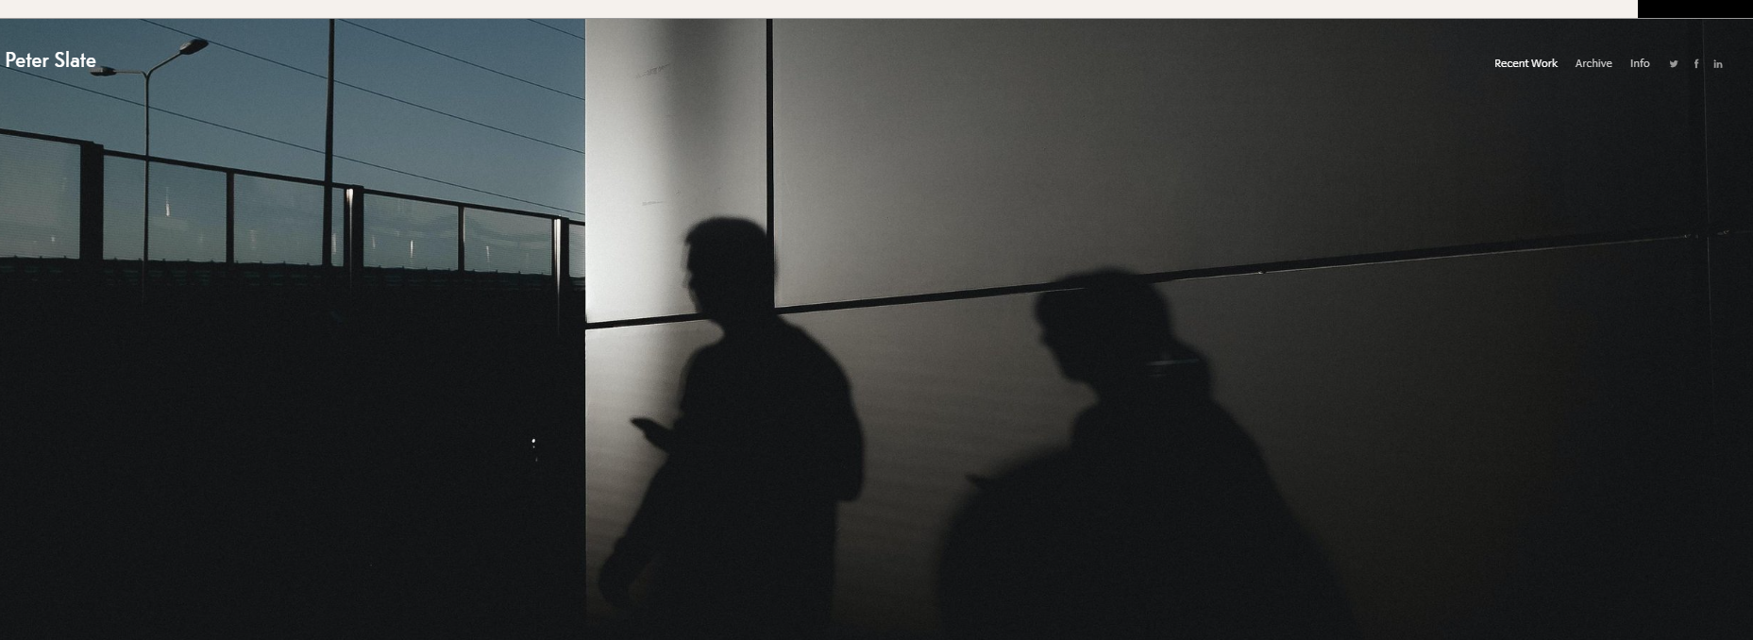

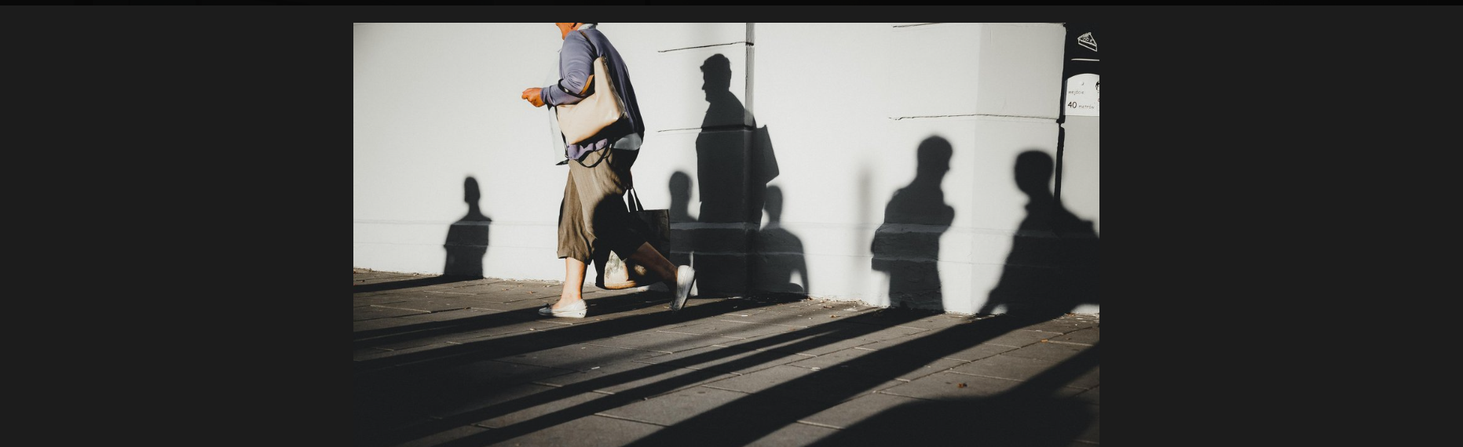

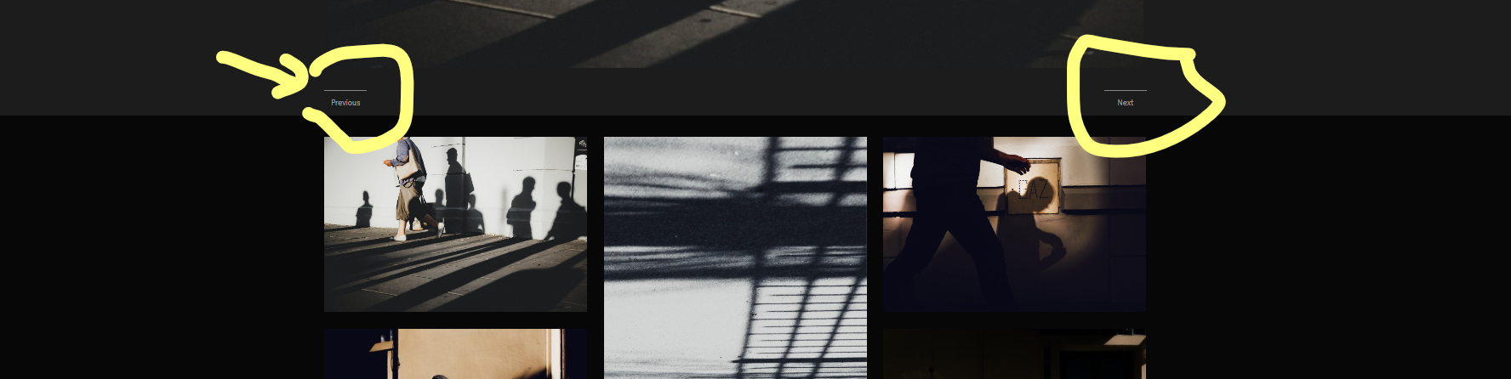

# Timelines

17 June > meeting => Kick Off

24 June > meeting

15 August > first complete draft ?

15 September > launch of the website, last tests + preparation of the communication campaign

15 October > communication campaign launch (organised by the gallery)

12 Novembre 2024 > exhibition

# Risk Log

Size of the pictures in high resolution making the website slow ?

Any copyright ?

# Budgets

None

# Lessons learned throughout the project